भारत मौसम विज्ञान विभाग |  | India Meteorological Department
Friday 15th May 2026 (25th Vaisakha 1948 Saka)
Summary of observations recorded at 0830 hours IST: The southwest monsoon is likely to set in over Kerala on 26th May with a model error of ± 4 days. Conditions are favourable for the advance of southwest monsoon over parts of south Bay of Bengal, Andaman Sea and Andaman & Nicobar Islands during next 24 hours. The well-marked low-pressure area over southwest & adjoining westcentral Bay of Bengal persisted over the same region at 0830 Hrs IST of today, the 15th May 2026 and the associated cyclonic circulation extends upto 5.8 km above m. s. l. tilting southwestwards with height. A Western Disturbance as a trough in middle tropospheric westerlies with its axis at 5.8 km above m. s. l. ran roughly along Long. 55°E to the north of Lat. 28°N at 2030 hrs IST of yesterday night. It ran roughly along Long. 60°E to the north of Lat. 28°N at 0530 hrs IST of today morning. It persisted over the same region at 0830 hrs IST. Another Western Disturbance as a cyclonic circulation over Jammu adjoining north Pakistan between 3.1 & 5.8 km above m. s. l. at 0530 hrs IST of today morning. It then persisted over the same region and seen at 3.1 km above m. s. l. An upper air cyclonic circulation lay over East Madhya Pradesh & neighbourhood at 0.9 km above m. s. l. The east-west trough from the upper air cyclonic circulation over southeast Madhya Pradesh to Sub-Himalayan West Bengal & Sikkim ran southeast Rajasthan to Sub-Himalayan West Bengal & Sikkim at 0530 hrs IST of today morning. It ran from West Madhya Pradesh to North Bangladesh across cyclonic circulation over East Madhya Pradesh, Southeast Uttar Pradesh, Bihar and North Gangetic West Bengal at 0.9 km above m. s. l. The upper air cyclonic circulation over east Uttar Pradesh & neighbourhood lay over Bihar at 0.9 km above m. s. l. at 0530 hrs IST of today morning. It merged with the east-west trough. A trough ran from the upper air cyclonic circulation over East Madhya Pradesh to North Interior Karnataka across Vidarbha and Marathwada at 0.9 km above m. s. l. A trough ran from Vidarbha to well-marked low-pressure area over southwest & adjoining westcentral Bay of Bengal across Marathwada, North Interior Karnataka, Rayalaseema and north Tamil Nadu at 0.9 km above m. s. l. at 0530 hrs IST of today morning. It became less marked at 0830 hrs IST. The upper air cyclonic circulation over North Interior Karnataka & neighbourhood became less marked. The upper air cyclonic circulation over west Uttar Pradesh & neighbourhood became less marked at 0530 hrs IST of today morning. The upper air cyclonic circulation over east Bangladesh & neighbourhood became less marked at 0530 hrs IST of today morning. The upper air cyclonic circulation over southeast Madhya Pradesh & neighbourhood became less marked at 0530 hrs IST of today morning.
Maximum Temperature Departures (as on 14-05-2026):Maximum temperatures are markedly above normal (5.1°C or more) at isolated places over Saurashtra & Kutch, West Madhya Pradesh; appreciably above normal (3.1°C to 5.0°C) at a few places over Gujarat Region; at isolated places over Jharkhand, Madhya Maharashtra, Vidarbha, West Rajasthan; above normal (1.6°C to 3.0°C) at most places over Marathwada; at many places over Coastal Karnataka; at a few places over East Madhya Pradesh, East Rajasthan, Himachal Pradesh, Konkan & Goa; at isolated places over Assam & Meghalaya, East Uttar Pradesh, Gangetic West Bengal, Kerala & Mahe, Odisha, Tamil Nadu, Puducherry & Karaikal, Uttarakhand, West Uttar Pradesh and near normal/ Below Normal over rest parts of the country. The highest maximum temperature of 45.9°C was reported at Akola (Maharashtra).
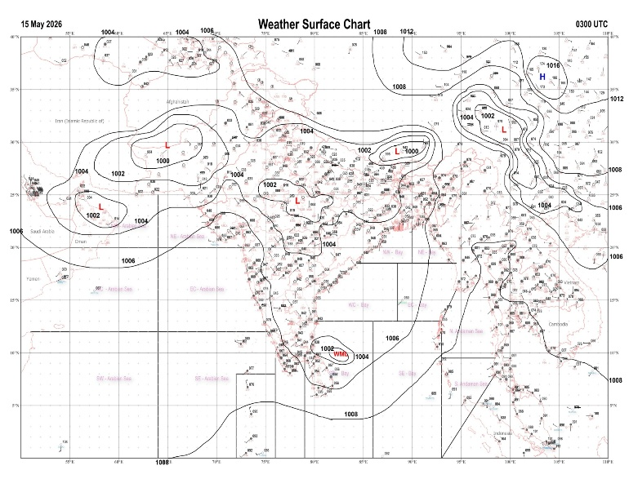 | 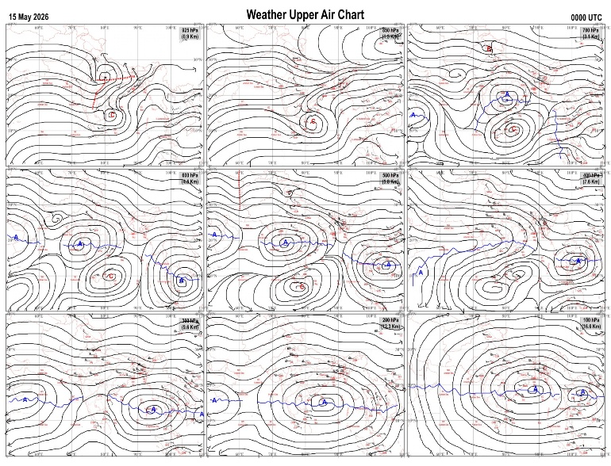
Fig.1. Analysed surface chart based on 03z observation | Fig.2. Analysed upper air chart based on 00z observation
Dr. S.D.Sanap
Scientist ‘D’
CR & S Office, Pune  Issued at 1245 hrs. IST |  | Weather Forecasting Division  CR&S, Pune

Indian regions | Realised rainfall (chief amount in cm during past 24 hrs):
East | most places: Arunachal Pradesh+  many places: Assam & Meghalaya#, Nagaland-Manipur-Mizoram-Tripura and Sub-Himalayan West Bengal & Sikkim+  isolated places: Odisha, Jharkhand and Bihar  dry weather: Gangetic West Bengal  B p ghat 26.5, Karimganj 15.2, Bhatkawa tea estate 10.6, Jalpaiguri 9.8, Dima tea estate 8.4, Haflong 8.0, Tuting 6.6, Wokha AWS 4.9, Seppa 4.3, Chottabekra 3.8, Patnagarh 2.3, Jharbandh & Titlagarh 1.8 each, Ziro 1.7, Agartala AP 1.5, Kolebira & Bankey bazar 0.5 each, Jaganathpur bau kvk AWS 0.3.
North | isolated places: east Uttar Pradesh◆, Uttarakhand, Haryana, Punjab, Jammu-Kashmir and Ladakh and Rajasthan  dry weather: west Uttar Pradesh and Himachal Pradesh  Nowgam 2.9, Sambhar SR 1.3, Jakhal mandi hmo, Anupgarh tehsil SR & Srivijaynagar SR 1.2 each, Jind 1.1, Ranewali irr, Amritsar & Jayal SR 1.0 each, Chirawa 0.8, Baramulla kvk AWS 0.5, Didihat, Raj pura ARG & Jaipur AP 0.4 each, Barnala 0.3, Narendranagar 0.2, Bhognipur, Ghatampur & Narnaul 0.1 each.
Central | isolated places: west Madhya Pradesh◆, east Madhya Pradesh, Vidarbha and Chhattisgarh  Kashdol 5.6, Sonakhan 4.3, Mawai 1.8, Bilaspur 1.5, Nowrozabad 1.3, Malanjkhand 0.7, Chandrapur 0.6.
Peninsula | most places: coastal Karnataka+  many places: Kerala+  a few places: north interior Karnataka+ and south interior Karnataka  isolated places: Konkan & Goa, Madhya Maharashtra, Marathwada, coastal Andhra Pradesh, Telangana, Rayalaseema and Tamil Nadu  dry weather: Gujarat State  Padannakkad AWS 8.6, Tellichery 7.6, Aurad 6.6, Ankola 6.5, Joida & Lokapur 6.0 each, Honavar 5.5, Haveri PTO 5.4, Napoklu 3.3, Hunchadakatte 3.0, Manamelkudi & Punalur 2.7 each, Paderu 1.6, Madnur 1.4, Tondapur ARG, Jukkal, Oothu & Ap peelamedu 1.2 each, Ardhapur & Shivamogga PTO 1.0 each, Sanguem, Udgir IMD parttime & Guntakal 0.5 each, Margao, Dabolim n.a.s. navy, Chandgad & Settur 0.4 each, Polavaram 0.2, Gadhinglaj & Nizamabad 0.1 each.
Islands | most places: Andaman & Nicobar  a few places: Lakshadweep+  Minicoy 8.7, Maya bandar 2.8, Hut bay 2.1, Car Nicobar 1.4.
Table-2 Forecast / warnings (distribution of rain / thundershowers) for 7 days (valid from time of origin upto 0830 hrs IST of next day)
Sr N. |  | Sub-division Name | Day 1 | Day 2 | Day 3 | Day 4 | Day 5 | Day 6 | Day 7 | Sr. No. | Sub-division Name | Day 1 | Day 2 | Day 3 | Day 4 | Day 5 | Day 6 | Day 7
 |  |  | 15 May | 16 May | 17 May | 18 May | 19 May | 20 May | 21 May |  |  | 15 May | 16 May | 17 May | 18 May | 19 May | 20 May | 21 May
 | 1 | Andaman Nicobar Islands | W +  | W ++  | W ++  | W +  | W  | W  | W  | 19 | west Madhya Pradesh | D + | D + | D + | D + | D + | D + | D +
 | 2 | Arunachal Pradesh | W +  | F +  | F +  | F | S | F + | W + | 20 | east Madhya Pradesh | I+ | D + | D + | D + | D + | D + | D+
 | 3 | Assam-Meghalaya | W++ | F+ | F+ | F +  | S +  | F + | W + | 21 | Gujarat region | D | D | D | D | D | D | D
 | 4 | Nagaland-Manipur-Mizoram-Tripura | F +  | S  | S  | F  | F | F + | F + | 22 | Saurashtra and Kutch | D + | D | D | D | D | D | D
 | 5 | Sub Him West Bengal/Sikkim | W +  | W +  | W ++  | F +  | S  | S | F | 23 | Konkan and Goa | I  + | I  + | I  | I | I | I | I
 | 6 | Gangetic West Bengal | S  | I  | I | S | S | S | S | 24 | Madhya Maharashtra | I  + | I  | I  | I  | I | I | I
 | 7 | Odisha | I  | I  | I  | I  | I  | I | I | 25 | Marathwada | I+ | I  | I  | I  | I | I | I
 | 8 | Jharkhand | I  | I  + | I  + | S  + | I  | I  | I  | 26 | Vidarbha | D + | D + | D + | D + | D + | D+ | D+
 | 9 | Bihar | I  | F  | S  | I  | I  | S | I | 27 | Chhattisgarh | I  | I  | I  | I + | D + | D + | D+
 | 10 | east Uttar Pradesh | I  | D + | D + | D + | D + | I + | I+ | 28 | Coastal Andhra Pradesh and Yanam | I  | I  | I  | I  | I  | I | I
 | 11 | west Uttar Pradesh | I  | D + | D + | D + | D + | D + | D+ | 29 | Telangana | I  | I  | D | D | D | D | D
 | 12 | Uttarakhand | I  | I  | I | D | D | I | I | 30 | Rayalaseema | I  | S  | S  | I  | I  | I | I
 | 13 | Haryana,Chandigarh and Delhi | I  | D | D + | D + | D + | D+ | D+ | 31 | Tamil Nadu, Puducherry and Karaikal | S + | I +  | S+ | S  | S  | I | I
 | 14 | Punjab | I  | D | D + | D + | D + | D + | D+ | 32 | Coastal Karnataka | S  | I | I | I | I | I | I
 | 15 | Himachal Pradesh | I  | I  | I | D | D | D | D | 33 | North interior Karnataka | S | I  | I  | I  | D  | D | D
 | 16 | Jammu-Kashmir and Ladakh | F  | F  | D | D | S | S | I | 34 | South interior Karnataka | S + | S +  | S+ | S + | I  | I | I
 | 17 | west Rajasthan | I+ | D + | D + | D + | D + | D + | D+ | 35 | Kerala and Mahe | W ++ | W + | W+ | W  | F  | F | F
 | 18 | east Rajasthan | I  | I+ | D + | D + | D + | D + | D+ | 36 | Lakshadweep | W+ | W  | W | F | F | F | F
Legends: D = Dry I =isolated S = Scattered F = Fairly widespread W = Widespread #= heavy to very heavy rain at a few places with extremely heavy rain at isolated places+++= heavy rain at a few places with very heavy rain at isoIated places++= heavy to very heavy rainfall @=isolated exceptionally heavy rainfall+ = heavy rain ●/*= rain or snow ♦ = very light rain ≡=fog = thunderstorm with lightning =Squall / Gusty / gale / strong wind -=cold wave/cold day + = heat wave/warm night/hot and humid weather =Duststorm =ground frost = Hail.

Fig. 4: Districtwise warnings for five days for Maharashtra State
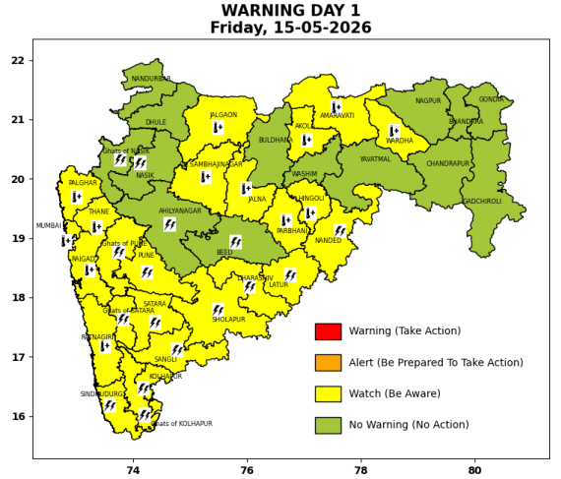 | 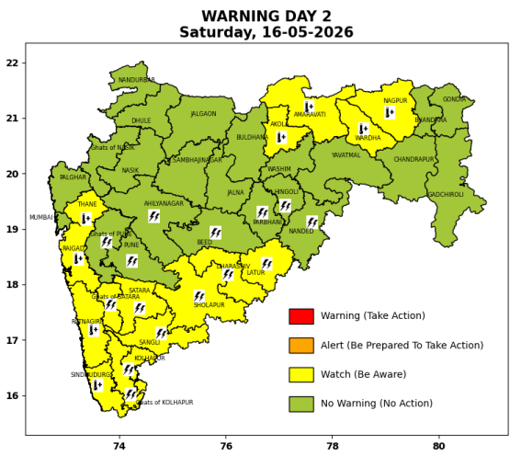 | 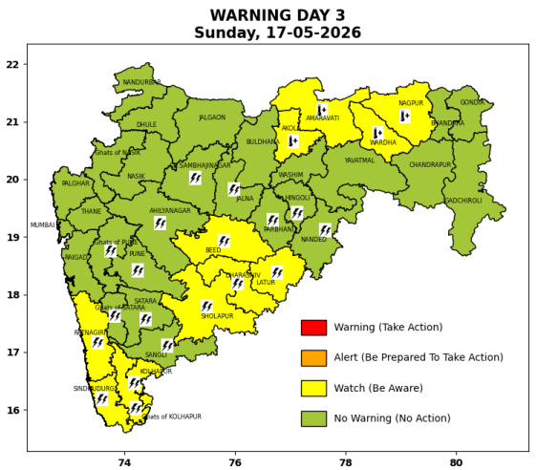 | 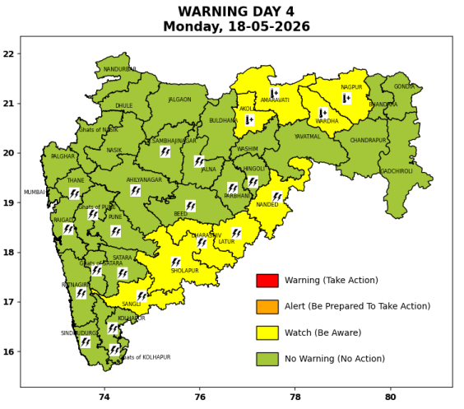 | 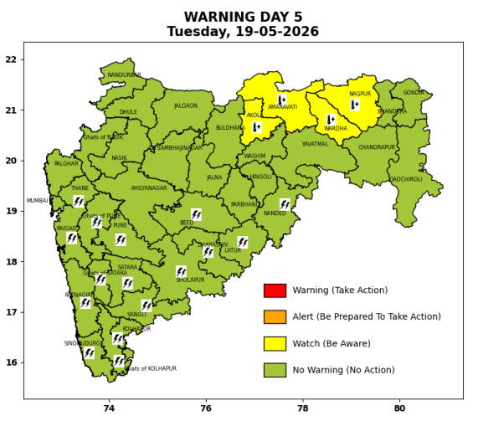

Pune, Lohegaon and Pashan observations at 0830 hrs. IST of Today
 | Temperature (°C) |  |  |  |  | Humidity (%) |  |  |  | Rainfall (mm)
 | Max.  past  24 hrs | Dep.  from  normal | Min.  past  24 hrs. | Dep.  from  normal | Dry  Bulb | At 0830 hrs. IST | Dep.  From  normal | At 1730  hrs. IST of y’day | Dep.  from  normal | Past  24 hrs. | Since  1st March | Dep.  from  normal
PNE | 38.6 | 1.1 | 25.7 | 3.4 | 29.0 | 47 | -8 | 31 | -3 | 0.0 | 92.8 | 69.1
PSN | - | - | 23.6 | - | 27.4 | 60 | - | - | - | 0.0 | - | -
LHG | 41.3 | 3.3 | 27.0 | 6.0 | 30.6 | 39 | -19 | 21 | -11 | 0.0 | 91.4 | 62.2

 |  |  |  |  |  |  | Local (Pune and neighbourhood) forecast
Max./Min. Temperature (°C) |  |  |  |  |  |  |  |  | Weather
Date | Pune | Pashan | Lohegaon | Chinchwad | Lavale | Magarpatta | NDA | Koregoan park
15/05/26 | 37 / 25.7* | 37 / 23.6* | 39 / 27.0* | 36 / 26.4* | 36 / 23.3* | 39 / 27.7* | 36 / 22.9* | 37 / 27.4* | Mainly clear sky becoming partly cloudy sky towards afternoon or evening.
16/05/26 | 40 / 25 | 39 / 23 | 42 / 26 | 38 / 26 | 38 / 23 | 40 / 27 | 38 / 23 | 39 / 27 | Mainly clear sky becoming partly cloudy sky towards afternoon or evening.
17/05/26 | 40 / 25 | 39 / 23 | 42 / 26 | 38 / 26 | 38 / 23 | 40 / 27 | 38 / 23 | 39 / 27 | Mainly clear sky becoming partly cloudy sky towards afternoon or evening.
18/05/26 | 39 / 25 | 38 / 23 | 41 / 26 | 37 / 26 | 37 / 23 | 39 / 27 | 37 / 23 | 38 / 27 | Mainly clear sky becoming partly cloudy sky towards afternoon or evening.
19/05/26 | 39 / 24 | 38 / 22 | 41 / 25 | 37 / 25 | 37 / 22 | 39 / 26 | 37 / 22 | 38 / 26 | Partly cloudy sky.
20/05/26 | 38 / 24 | 37 / 22 | 40 / 25 | 36 / 25 | 36 / 22 | 38 / 26 | 36 / 22 | 37 / 26 | Partly cloudy sky.
21/05/26 | 38 / 24 | 37 / 22 | 40 / 25 | 36 / 25 | 36 / 22 | 38 / 26 | 36 / 22 | 37 / 26 | Partly cloudy sky.
Rainfall Distribution |  |  |  |  | Rainfall Categories | Rainfall (mm) | Cloud condition |  | Rainfall Intensity | Range
Widespread (W) | 76-100% |  |  |  | Very Light rain | Trace to 2.4 mm | Mainly clear sky | 1-2 oktas | Light Spell | 1 cm/hr
 |  |  |  |  | Light rain | 2.5 to 15.5 mm | Partly cloudy sky | 3-4 oktas | Moderate Spell | 1-2 cm/hr
Fairly Widespread (FW) | 51 – 75% |  |  |  | Moderate rain | 15.6 to 64.4 mm | Generally cloudy sky | 5-7 oktas | Intense Spell | 2-3 cm/hr
Scattered (S) | 26 – 50% |  |  |  | Heavy rain | 64.5 to 115.5 mm | Overcast | 8 oktas | Very Intense Spell | 3-5 cm/hr
Isolated (I) | 1 – 25% |  |  |  | Very heavy rain | 115.6 to 204.4 mm |  |  | Extremely Intense Spell | 5-10 cm/hr
Dry (D) | No Rain |  |  |  | Extremely heavy rain | ≥ 204.5 mm |  |  | Cloudburst | > 10 cm/hr
Probability Terms in %: |  |  |  |  | Heavy snow | 6.5 to 11.5 cms water equivalent of rain
unlikely | < 25 |  |  |  | Very heavy snow | 11.6 to 20.4 cms water equivalent of rain
likely | between 25 50
very likely | between 51 75
most likely | >75
* = realized temperatu
Mumbai (Colaba) |  |  |  | Nagpur (AP)
Date 2026 | T max °C | T min °C | Weather | T max °C | T min °C | Weather
15/05/26 | 35 | 28 | Clear sky. | 44 | 27 | Partly cloudy sky.
16/05/26 | 35 | 28 | Clear sky. | 45 | 26 | Heat Wave.
17/05/26 | 34 | 28 | Clear sky. | 45 | 26 | Heat Wave.
18/05/26 | 34 | 28 | Clear sky. | 45 | 26 | Heat Wave.
19/05/26 | 34 | 28 | Clear sky. | 45 | 26 | Heat Wave.
20/05/26 | 34 | 28 | Clear sky. | 45 | 26 | Heat Wave.
21/05/26 | 34 | 28 | Clear sky. | 45 | 26 | Heat Wave.

